Practical – 6

Practical Title: Rendering External JSON Data using Fetch API, Search and Filter

Problem Definition: Display event lists, student profiles, notices, or FAQs from external JSON files using Fetch API. Implement dynamic rendering, search, filter, sorting, and pagination.

Theory
References for all questions:
https://developer.mozilla.org/en-US/docs/Web/API/Fetch_API

1. How is JSON fetched, parsed, and rendered?
Answer: JSON data is fetched using fetch(), parsed using .json(), and displayed on the webpage using DOM methods.

2. Which array methods are used for search, filter, sort, and pagination?
Answer: find() is used for search, filter() for filtering, sort() for sorting, and slice() for pagination.

3.How are loading and error states handled?
Answer: Loading messages are displayed while fetching data, and try...catch is used to handle errors and display error messages.

4.How is modularity maintained in JavaScript files?
Answer: Modularity is maintained by dividing code into separate files and using export and import to share functions and data.

Implementation/ Output/Result

The program was created using HTML and JavaScript. JavaScript was used to fetch, filter, sort, and display data. Loading and error messages were handled properly. The program was successfully implemented.

Evidence of Work (Screenshots)

Description: Figure 6.1 events page
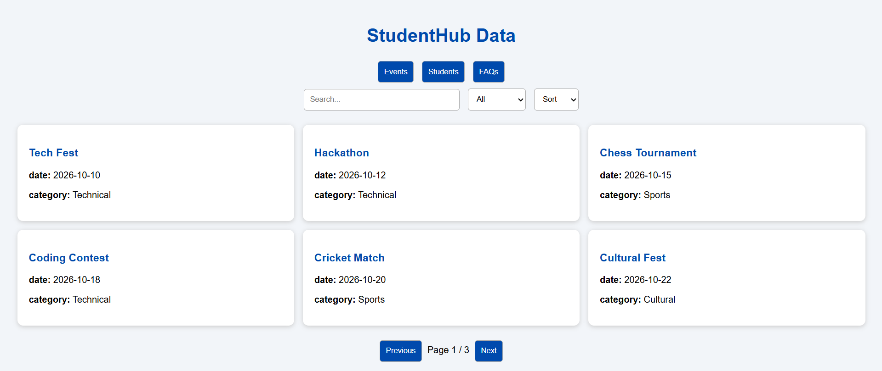

Description: Figure 6.2 student page
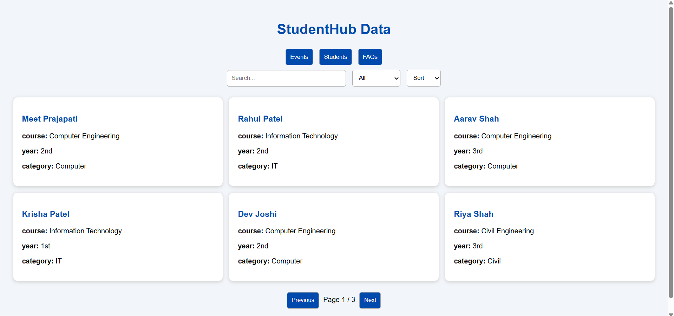
Description: Figure 6.3 FAQ page
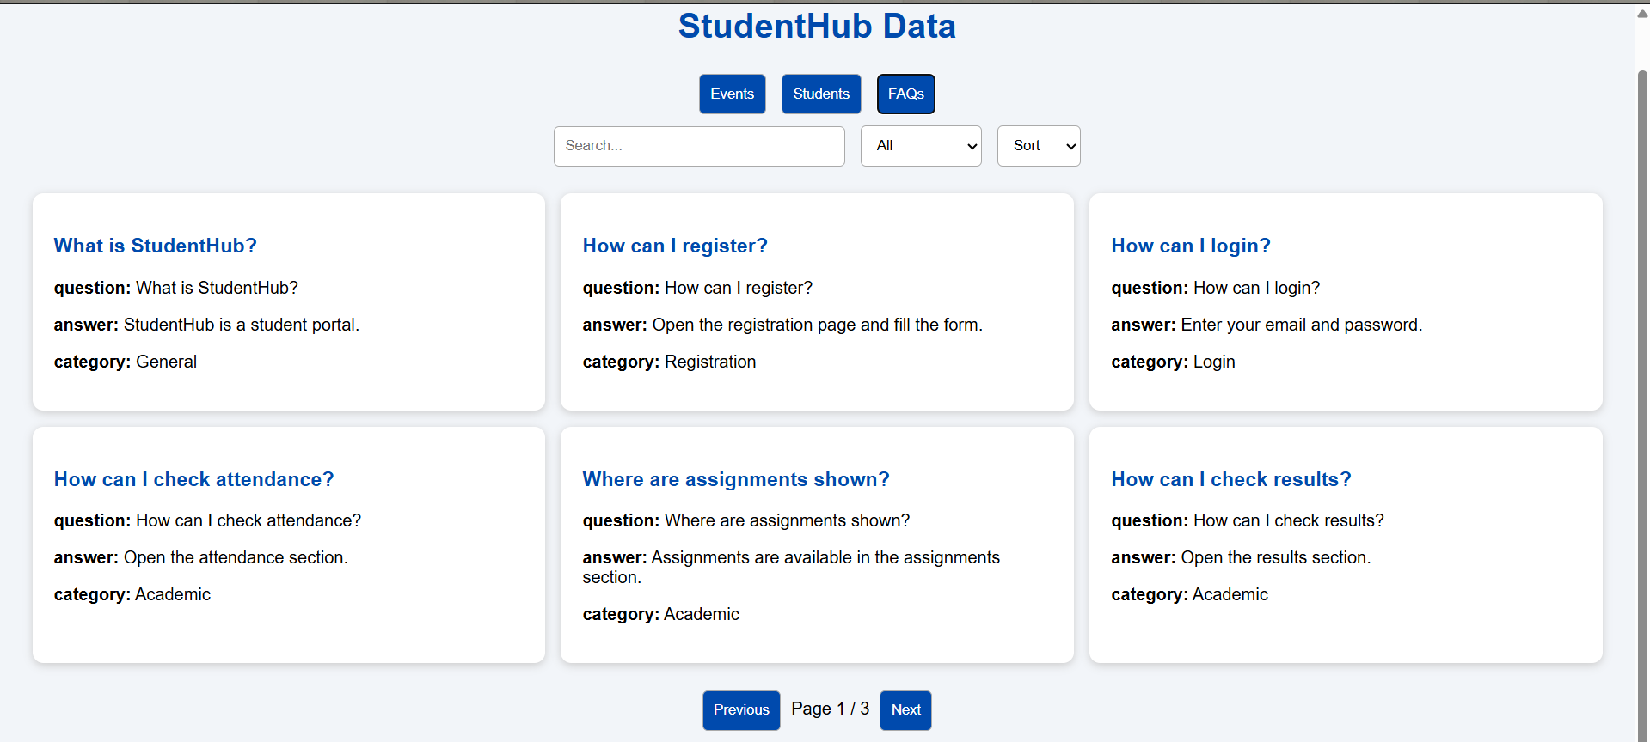

D. GitHub Repository Link:
Link: https://github.com/meetp2m/WDF-PRACTICAL-6

Challenges Faced:

Answer: The main challenge was understanding JavaScript validation.
I faced some difficulty in checking the password and confirm password.

F. Learning Outcomes:

Answer: I learned how to fetch and display JSON data and also • Learned to search, filter, sort, and paginate data.

G. Faculty Remarks:

